

ARCHITECTURAL VISUALIZATION IN VIRTUAL REALITY

Internship Report

Done by

Aishwariya.R,

  B.E. computer science and engineering

Sri Ramakrishna engineering college, Coimbatore-641022

Internship at:

PRICOL TECHNOLOGIES,

RAMANATHAPURAM, Coimbatore-641045

  Supervisors:

MR.Vinayan

MR.Sudesh karatha

Start Date for Internship: 27th february, 2017

End Date for Internship: 16th June, 2017

Report Date: 16th June, 2017

**PRICOL TECHNOLOGIES**

**BONAFIDE CERTIFICATE**

certified that this project report **“Architectural Visualization”** is the bonafide work of

**Aishwariya.R**

who carried out the project work under my supervision.

Signature: Signature: ------------------------- -------------------------

Name**: VINAYAN** Name: **SUDESH KARATHA**

**FIELD SUPERVISOR HEAD OF THE INDUSTRIAL DESIGN**

Pricol Technologies **AND VISUALIZATION TEAM**

Design Engineer Pricol Technologies

Practice Manager

**DECLARATION**

I declare that this internship report is my own original work. Where other people’s work has been used, I have correctly acknowledged it with accordance to the university standards. I confirm that I have not used work previously produced by another student or any other person to hand in as my own. I have not allowed and I will not allow anyone to copy my work with intention of passing it off as her own work.

**Signature** ………………………………………………………

(Aishwariya.R)

I certify that the declaration made above by the candidate is true.

----------------------------------------

**Signature of the supervisor**

(Mr.Vinayan)

PREFACE

From february 2017 till june 2017, I did an internship at “ **Pricol Technologies**”, a global engineering solutions provider enabling companies to conceptualize, design and manufacture products. Operating in different sectors such as transportation (automotive, rail and aerospace), consumer products, industrial products and medical devices, having a clientele spread across the globe. With operations in the united states, europe, india and africa worked closely with customers sharing their commitment and focus for their businesses. Pricol Technologies offers a wide range of services in the area of embedded systems, mechanical design, industrial design, prototyping, testing support and batch/contract manufacturing helping customers realize their product from concept to manufacturing. Pricol Technologies is the engineering division of the 40 year, $350 million Pricol group (www.Pricol.com) a diverse business house with interests in the area of  automotive parts, rail & defense, aftermarket, reality, packaging & hospitality.

ACKNOWLEDGEMENT

The internship opportunity i had with Pricol Technologies was a great chance for learning and professional development. Therefore, I consider myself as a very lucky individual as i was provided with an opportunity to be a part of it. I am also grateful for having a chance to meet so many wonderful people and professionals who led me though this internship period. I have taken efforts in this project. However, it would not have been possible without the kind support and help of many individuals and organizations.

I would like to extend my sincere thanks to all of them. I am very appreciated to Mr. Vinayan, my supervisor at Pricol Technologies. Vinyan gave me very in-time valuable instructions who gave me extensive guidance throughout the internship. I also would like to express my gratitude to Mr.Sudesh more importantly for his enthusiastic encouragements and precious instructions during my internship period. He gave me in-time feedback on my research and helped to organize an interesting presentation in which i could present my ideas and achievements to professionals in the organization.

Throughout the internship, I have also learnt many things about the industrial design and visualization whose benefits are far beyond what I could learn in a normal project. In short, I would like to thank Pricol Technologies for introducing me to this great opportunity in which I have developed myself both academically, professionally and socially.

LIST OF FIGURES

|  |  |  |  |
| --- | --- | --- | --- |
| SERIAL NUMBER | FIGURE NUMBER | TITLE | PAGE NUMBER |
| 1 | 1.1.a | picture of a person experiencing vr | 10 |
| 2 | 1.1. b | sterographic view | 11 |
| 3 | 1.1.c | google cardboard | 13 |
| 4 | 1.1.d | picture of htc vive and oculus rift | 14 |
| 5 | 1.1.e | Microsoft Hololens | 15 |
| 6 | 2.1.a | user gazing at the chair | 20 |
| 7 | 2.1.b | the chair is rotated after 2 seconds | 20 |
| 8 | 2.1.c | user gazes at the floor | 24 |
| 9 | 2.1.d | the material of the floor changes to material 2. | 24 |
| 10 | 2.1.e | the material of the floor changes to material 3. | 25 |
| 11 | 2.1.f | hmd used | 26 |
| 12 | 2.2.a | scene01 | 34 |
| 13 | 2.2.b | scene02 | 34 |
| 14 | 2.2.c | scene03 | 35 |
| 15 | 2.2.d | panaromic image of car showroom-1 | 35 |
| 16 | 2.2.e | panaromic image of car showroom-2 | 36 |
| 17 | 2.2.f | panaromic image of car showroom-3 | 36 |
| 18 | 2.2.g | vr box | 37 |
| 19 | 2.3.a | The welcoming page of the app | 43 |
| 20 | 2.3.b | image of sofa model with buttons | 43 |
| 21 | 2.3.c | image of chair model with buttons | 44 |
| 22 | 2.3.d | Touch interaction | 45 |

LIST OF ABBREVIATION

MC -main camera

SDK-software development kit

VR-virtual Reality

HMD-head mounted display

**TABLE OF CONTENT**

|  |  |  |  |
| --- | --- | --- | --- |
| **CHAPTER** |  | **TITLE** | **PAGE NO.** |
| **1** | **1.1**    **1.1.1**    **1.2**      **1.2.1**    **1.3** | **INTRODUCTION**  **Virtual Reality**  **Application**  **Head Mounted Display**  **Types**  **Unity3D** | 10  11    11  12  15 |
| **2** | **2.1**  **2.1.1**    **2.1.2**  **2.1.3**  **2.1.4**  **2.2**  **2.2.1**  **2.2.2**    **2.2.3**  **2.2.4**  **2.3**  **2.3.1**  **2.3.2**  **2.3.3**  **2.3.4** | **Projects and its modules**  LIVING ROOM IN VIRTUAL REALITY  LIVING ROOM  DESIGNING  CODING AND GAZE INTERACTION  Synchronization  Car showroom in virtual reality  Car Showroom  Designing  Coding and gaze interaction  Synchronization  Use touch gestures to rotate a 3d model  Touch app  Designing  Coding and touch interaction  Synchronization | 16  16  16  17  25  26  26  27  29  36  38    38  38  39  44 |
| **3** | **3.1** | **CONCLUSION** | 46 |

CHAPTER 1

Introduction

1.1 VIRTUAL REALITY

Virtual Reality (VR) is the use of computer technology to create a simulated environment. Unlike traditional user interfaces, VR places the user inside an experience. Instead of viewing a screen in front of them, users are immersed and able to interact with 3D worlds. By simulating as many senses as possible, such as vision, hearing, [touch](http://en.wikipedia.org/wiki/Haptic_technology), even [smell](http://feelreal.com/), the computer is transformed into a gatekeeper to this artificial world. The only limits to near-real VR experiences are the availability of content and cheap computing power.

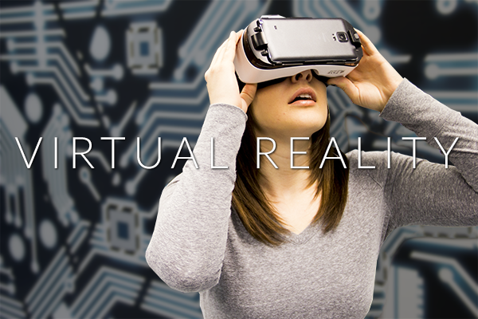

Fig 1.1a) picture of a person experiencing vr

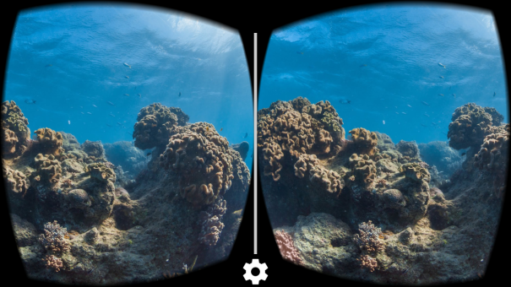

Fig 1.1b) sterographic view

* + 1. Applications
* Architecture
* Sport
* Medicine
* The Arts
* EDUCATION AND TRAINING
* THERAPY
* VIDEO GAMES
* Entertainment
  1. HEAD MOUNTED DISPLAY

A head-mounted display (HMD) is a type of computer display device or monitor that, as the name implies, is worn on the head or is built in as part of a helmet. This type of display is meant for a total immersion of the user in whatever experience the display is meant for, as it ensures that no matter where the user’s head may turn, the display is positioned right in front of the user's eyes. In most cases, this is a virtual reality or multimedia device meant for entertainment. However, some models have real-world applications such as part of the heads-up display used in special weapon systems such as in airplanes and helicopters.

* + 1. TYPES

[Slide-on HMD](https://xinreality.com/wiki/Slide-on_HMD) is the most primitive of all HMD types. These devices rely on the inserted smartphones to do all of the leg work. [Discrete HMD](https://xinreality.com/wiki/Discrete_HMD) contains a display and some electronics for [tracking](https://xinreality.com/wiki/Tracking) and other functions. While they are more advanced than the Slide-ons, Discrete HMDs still require connections to PCs for processing. [Integrated HMD](https://xinreality.com/wiki/Integrated_HMD) is the most sophisticated of them all. From display to tracking to processing, it has everything needed for VR or [AR](https://xinreality.com/wiki/AR) within the HMD.

### Slide-on HMD

[Slide-on HMD](https://xinreality.com/wiki/Slide-on_HMD), also known as Smartphone mount, is the cheapest and most accessible form of [VR](https://xinreality.com/wiki/VR). The Slide-on consists of a smartphone holder, [lenses](https://xinreality.com/wiki/Lenses) and some form of basic [input](https://xinreality.com/wiki/Input). A smartphone is inserted into the HMD and the entire device is played upon the eyes of the user to create the VR experience. The Slide-on utilizes the smartphone for display, processing and [rotational tracking](https://xinreality.com/wiki/Rotational_tracking). Some Slide-on HMDs such as the [Gear VR](https://xinreality.com/wiki/Gear_VR) use their own built-in [IMUs](https://xinreality.com/wiki/IMUs) instead of relying on that of the smartphones.

Popular Slide-on HMDs:

* [Google Cardboard](https://xinreality.com/wiki/Google_Cardboard)
* [Samsung Gear VR](https://xinreality.com/wiki/Samsung_Gear_VR)

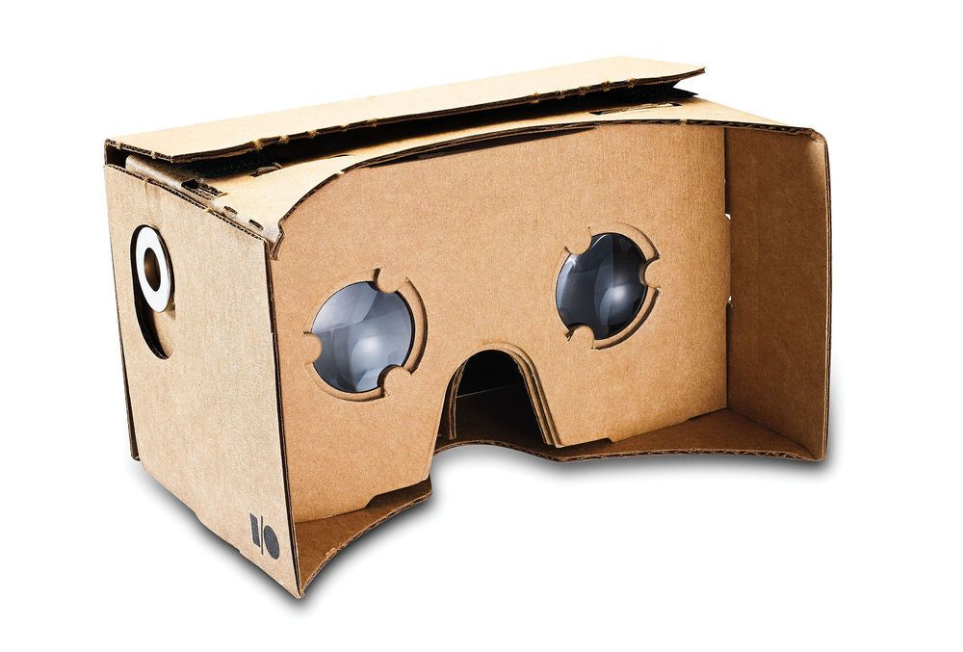

Fig1.1 c) google cardboard

### Discrete HMD

[Discrete HMD](https://xinreality.com/wiki/Discrete_HMD) also known as Tethered HMD supplies everything required for an [immersive](https://xinreality.com/wiki/Immersive) [VR](https://xinreality.com/wiki/VR) experience aside from the processing. It contains display, lenses, rotational tracking, [positional tracking](https://xinreality.com/wiki/Positional_tracking), audio and advanced input. For processing, Discrete HMDs are connected to PCs through cables. While this type of HMD is less mobile than its 2 counter parts, it is able to deliver the best VR experience.

Popular Discrete HMDs:

* [Oculus Rift](https://xinreality.com/wiki/Oculus_Rift)
* [HTC Vive](https://xinreality.com/wiki/HTC_Vive)
* [PlayStation VR](https://xinreality.com/wiki/PlayStation_VR)

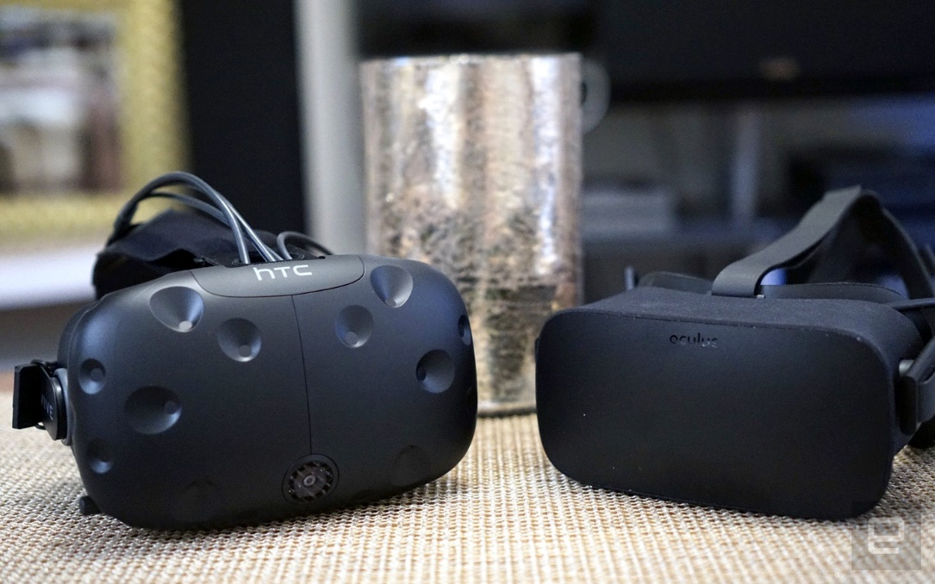

Fig 1.1 d) picture of htc vive and oculus rift

### Integrated HMD

[Integrated HMD](https://xinreality.com/wiki/Integrated_HMD) is the most sophisticated and expensive type of HMD and [OHMD](https://xinreality.com/wiki/OHMD). This independent computing device is able to deliver [VR](https://xinreality.com/wiki/VR) and/or [AR](https://xinreality.com/wiki/AR) experiences without any external hardware such as PC or smartphone. It contains everything from display to processors to camera and is able to display stereoscopic 3D images, perform complex tracking and utilize advanced input methods. Currently, most of Integrated HMDs are AR OHMDs with high price point and target only business professionals.

Popular Integrated HMDs:

* [Microsoft HoloLens](https://xinreality.com/wiki/Microsoft_HoloLens)
* [Google Glass](https://xinreality.com/wiki/Google_Glass)
* [Magic Leap](https://xinreality.com/wiki/Magic_Leap)

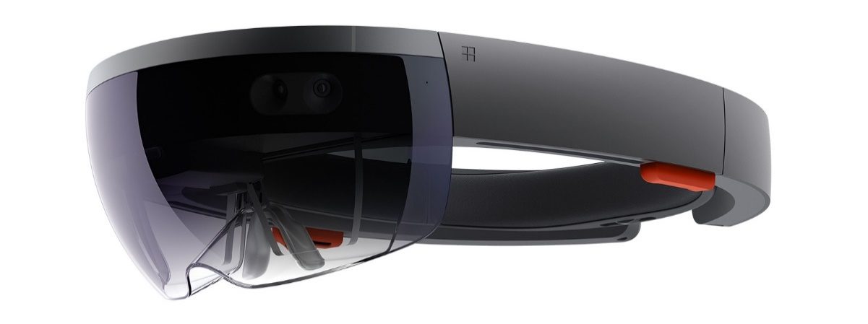

Fig 1.1 e) Microsoft Hololens

* 1. UNITY3D

A 3D engine of course, is a physics engine that handles the laws and behaviors of various game objects, it also handles the rendering of graphics, lighting and physics like gravity and momentum and may even have some gameplay elements included. If you want to create a 3D engine from scratch, you’ll need to code everything from the way a glass falls off a table down to the way it bounces and refracts light on the way down. Doing the same thing in Unity3D means making a 3D model of a glass, setting its mass and gravity and positioning it on a table in your game world – it’s the difference between a team working for months or one person making a few mouse clicks.

While many other 3D engines exist (such as the Unreal 4 Engine), Unity3D is one of the simplest and has an interface that makes it almost ‘game maker’ like. It also has the advantage of being truly cross platform – you can build a game in Unity3Dand then publish it to Android, iOS, Windows, Windows Mobile, MacOS, Linux… even PS4 and Xbox One. And because Unity lets you incorporate your own code, there’s really no limit to what’s possible. You can even make games that will support VR.

CHAPTER 2

PROJECT AND ITS MODULES

2.1 LIVING ROOM IN VIRTUAL REALITY

2.1.1 LIVING ROOM :-

The project “living room in virtual reality” is to visualize the living room to change the materials of the floor and also to rotate the furniture model which is an immersive and interactive environment.

2.1.2 DESIGNING :-

* In this project the software used to develop the project is “unity” . The designing of the 3d models were downloaded from the asset store in unity. The asset models that are used to create a living room are .fbx files of walls, floor, furniture models from hq classic arm chair, pack gesta furniture.
* Create materials for the floor using assets folder->right click->create->material

Initially we set the main camera and increased the skybox by changing the scale in the inspector settings and also useda directional light which is a typically simulates sunlight and a single light can illuminate the whole of a scene. Scenes contain the objects of our game.place all the objects in the scene and adjust the scale,transform and rotation using inspector settings. A material defines which shader to use for rendering this material.

2.1.3 CODING AND GAZE INTERACTION:-

In unity the programming language used is c#. Initially for stereographic view of vr the

Googlevrsdk 1.0.3 is used which has common vr development tasks such as:

* Lens distortion correction.
* Spatial audio.
* Head tracking.
* 3d calibration.
* Side-by-side rendering.
* Stereo geometry configuration.
* User input event handling.

->Gvrsdk->prefabs->gvr viewer main

->Gvrsdk->prefabs->ui->gvr reticle

->Delete main camera

->Add the component “physics raycaster”

->Create an event system and add an gaze input module

Create a script called “chair” this is used to rotate the chair if the user gazed at the chair for 2 seconds.

SOURCE CODE TO ROTATE THE CHAIR:

Using system.collections;

Using system.collections.generic;

Using unityengine;

Public class chair : monobehaviour {

public float gazetime = 2f;// gaze for 2 seconds

private float timer;

private bool gazedat;

// use this for initialization

void start () {

}

// update is called once per frame

void update () {

if (gazedat)

{

timer += time.deltatime;

if (timer >= gazetime)

{

transform.position += new vector3(0f, 1f, 0f);

timer = 0f;

}

}

}

public void pointerenter()

{

//debug.log("pointer enter");

gazedat = true;

}

public void pointerexit()

{

//debug.log("pointer exit");

gazedat = false;

}

public void pointerdown()

{

debug.log("pointer down");

}

}

Add this script to the chair and add a component called event trigger for pointer enter,pointer down ,pointer exit and set the functions .

Now play the project in the editor.

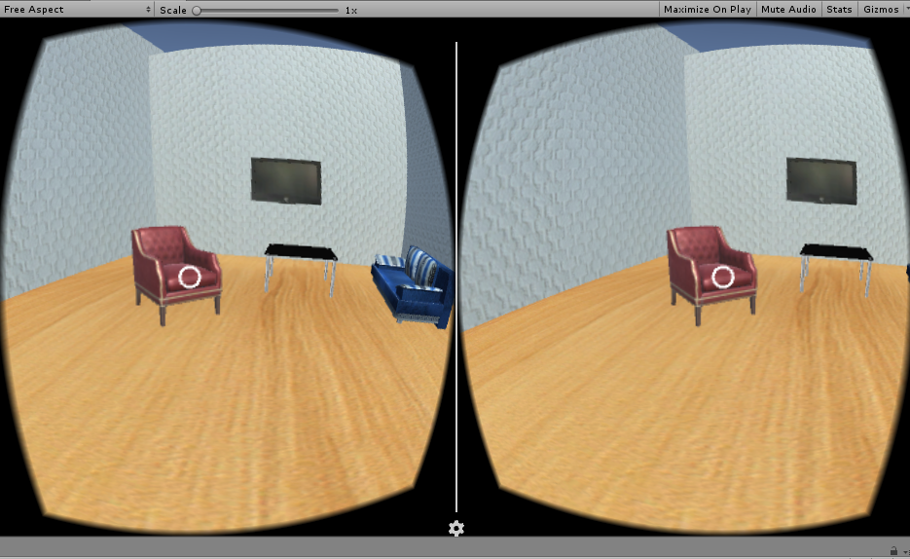

Fig 2.1a) user gazing at the chair

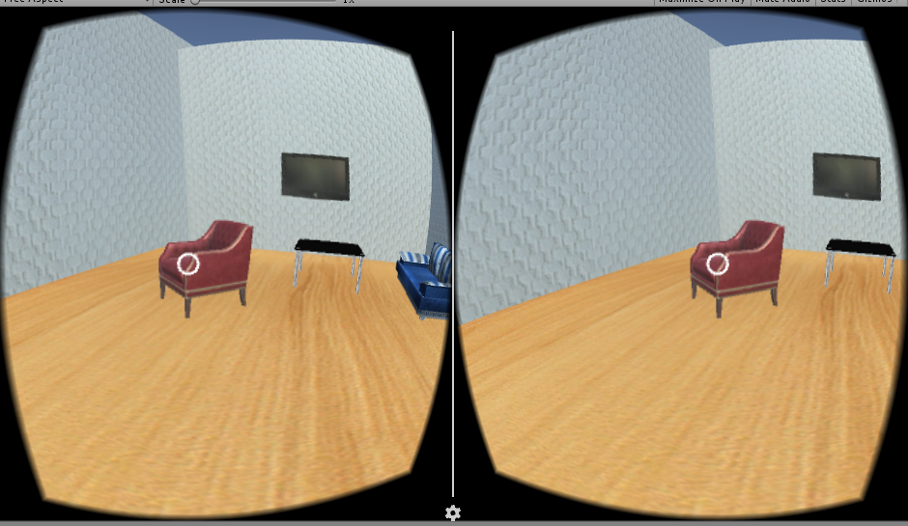

Fig 2.1 b) the chair is rotated after 2 seconds

Create a script called “floor” this is used to change the materials if the user gazed at the chair for 2 seconds.

SOURCE CODE TO CHANGE THE MATERIAL BY GAZING:

Using system.collections;

Using system.collections.generic;

Using unityengine;

//make sure to change the class name (ccsphere) to whatever you called your script.

Public class tochangematerial : monobehaviour

{

public float gazetime = 2f;

private float timer;

private bool gazedat;

public material[] materials;//allows input of material colors in a set size of array;

public renderer rend; //what are we rendering? Input object(sphere,cylinder,...) To render.

private int index = 1;//initialize at 1, otherwise you have to press the ball twice to change colors at first.

// use this for initialization

void start()

{

rend = getcomponent<renderer>();//gives functionality for the renderer

rend.enabled = true;//makes the rendered 3d object visable if enabled;

}

void update()

{

if (gazedat)

{

timer += time.deltatime;

if (timer >= gazetime)

{

if (materials.length == 0)//if there are no materials nothing happens.

return;

index += 1;//when mouse is pressed down we increment up to the next index location

if (index == materials.length + 1)//when it reaches the end of the materials it starts over.

index = 1;

print(index);//used for debugging

rend.sharedmaterial = materials[index - 1]; //this sets the material color values inside the index

timer = 0f;

}

}

}

public void pointerenter()

{

//debug.log("pointer enter");

gazedat = true;

}

public void pointerexit()

{

//debug.log("pointer exit");

gazedat = false;

}

}

Add this script to the floor and add a component called event trigger for pointer enter,pointer down ,pointer exit and set the functions .

Now play the project in the editor.

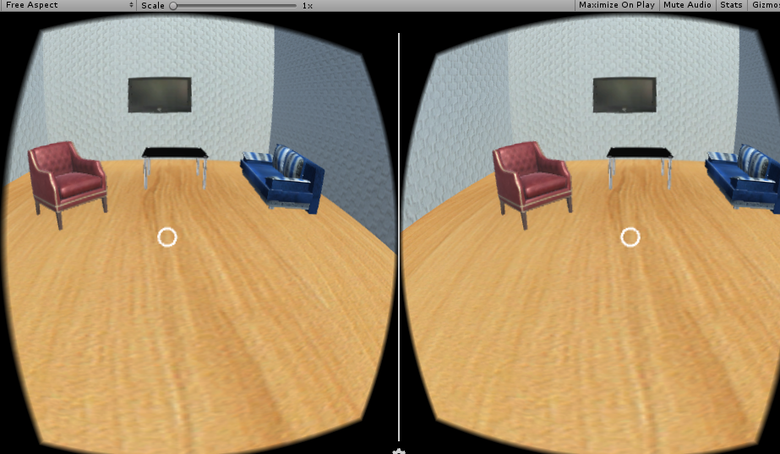

Fig 2.1 c) user gazes at the floor

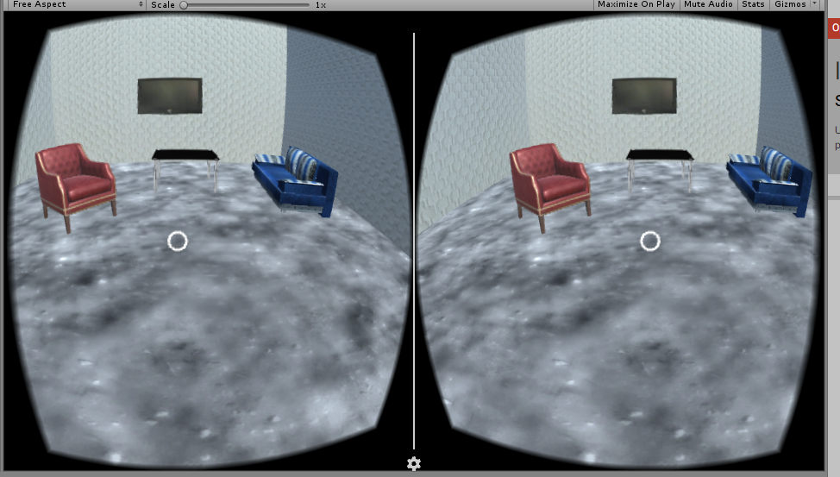

Fig 2.1 d) the material of the floor changes to material 2.

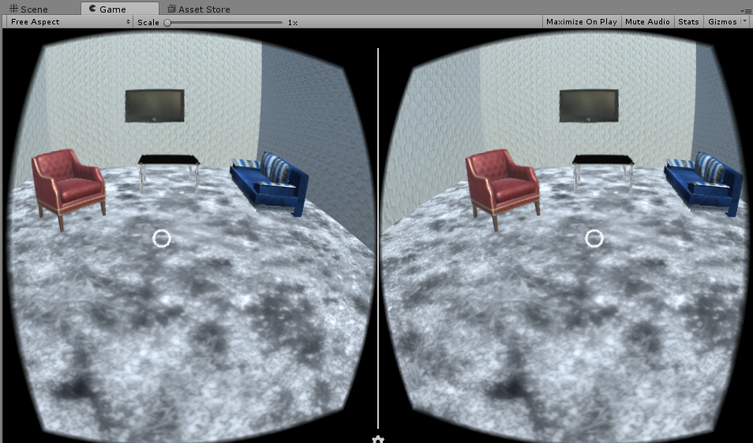

Fig 2.1 e) the material of the floor changes to material 3.

2.1.4 Synchronization

For synchronizing the application with the head mounted device we have to deploy the project as an android application. To do so we have to install the android sdks of api level 8 to apilevel 22.

The googlevrsdk has two cameras. One is for left eye and other one is for right eye.unity vr adds the ability to target vr devices from directly within unity without the need for external plugins. It provides a base api

And feature set with the goal forward compatability for devices and software.the provided api surface today is minimal by design and will expand as we learn more about the needs of vr developers to convert the unity project to android app we need android sdk and jdk. In the menu go to file->build settings->android->playersettings->identificaction->bundle identifier and set the name to be “com.gazeapp.project” in the meu go to file->build settings->android->click build and save the file extension as “.apk”.

We can interact with the android app using a hmd. Eg:vr box,google cardboard

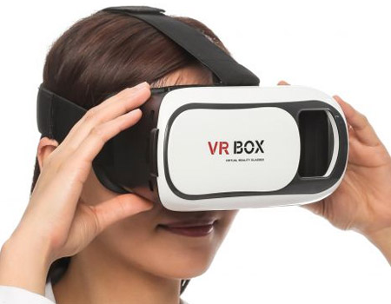

Figure 2.1 f) hmd used

2.2 CAR SHOWROOM IN VIRTUAL REALITY

2.2.1 CAR SHOWROOM:-

The project “ Car Showroom” in virtual reality is to visualize the car show room to move from one scene to other scene of the showroom in a virtual environment.

2.2.2 DESIGNING

* In this project the software used to develop the project is “unity” . The assets here are sequential panaromic images which are created by design engineers with a format of “.jpg”.
* The button used here is a 3d model.i.e .fbx file of a button.

Initially set the main camera inside the sphere by changing the position of both mc and sphere to( 0,0,0) ,in the inspector settings and also used a directional light which is a typically simulates sunlight and a single light can illuminate the whole of a scene. scenes contain the objects of our game.place all the objects in the scene and adjust the scale,transform and rotation using inspector setting. A Material defines which shader to use for rendering this material.

* To create a material-> ASSETS folder->right click->CREATE->MATERIAL and apply it to the sphere
* Since the given images are panaromic we have to use an equirectangular shader, apply the shader named ”rect” to the material.
* Now drag and drop the first image inside the sphere and save the scene as “scene01” and create 2 more scenes namely ”scene02”, ”scene03” with the second and third image.
* Here each scenes has 2 buttons.i.e scene01 has 2 buttons to go to scene 2 and scene3.likewise using scene 2 and 3 we can go to other scenes too.

**The code for shader:-**

Shader "Unlit/rect"{  
    Properties {  
          
        _MainTex (" Base (RGB)", 2D) = "gray" {}  
    }  
  
    SubShader{  
        Pass {  
            Tags {"RenderType"="Opaque" }  
         cull front  
            CGPROGRAM  
                #pragma vertex vert  
                #pragma fragment frag  
                #pragma fragmentoption ARB_precision_hint_fastest  
                #pragma glsl  
                #pragma target 3.0  
  
                #include "UnityCG.cginc"  
  
                struct appdata {  
                   float4 vertex : POSITION;  
                   float3 normal : NORMAL;  
                };  
  
                struct v2f  
                {  
                    float4    pos : SV_POSITION;  
                    float3    normal : TEXCOORD0;  
                };  
  
                v2f vert (appdata v)  
                {  
                    v2f o;  
                    o.pos = mul(UNITY_MATRIX_MVP, v.vertex);  
                    o.normal = v.normal;  
                    return o;  
                }  
  
                sampler2D _MainTex;  
  
                #define PI 3.141592653589793  
  
                inline float2 RadialCoords(float3 a_coords)  
                {  
                    float3 a_coords_n = normalize(a_coords);  
                    float lon = atan2(a_coords_n.z, a_coords_n.x);  
                    float lat = acos(a_coords_n.y);  
                    float2 sphereCoords = float2(lon, lat) * (1.0 / PI);  
                    return float2(sphereCoords.x * 0.5 + 0.5, 1 - sphereCoords.y);  
                }  
  
                float4 frag(v2f IN) : COLOR  
                {  
                    float2 equiUV = RadialCoords(IN.normal);  
                    return tex2D(_MainTex, equiUV);  
                }  
            ENDCG  
        }  
    }  
    FallBack "VertexLit"  
}

2.2.3 CODING AND GAZE INTERACTION:-

In unity the programming language used is c#. Initially for stereographic view of vr the

Googlevrsdk 1.0.3 is used which has common vr development tasks such as:

* Lens distortion correction.
* Spatial audio.
* Head tracking.
* 3D calibration.
* Side-by-side rendering.
* Stereo geometry configuration.
* User input event handling.

->Gvrsdk->prefabs->gvr viewer main

->Gvrsdk->prefabs->ui->gvr reticle

->Delete main camera

->Add the component “physics raycaster”

->Create an event system and add an gaze input module

Create a script called “button1” this is used to go to scene02 if the user gazed at the button for 2 seconds.

SOURCE CODE :-

using System.Collections;  
using System.Collections.Generic;  
using UnityEngine;  
using UnityEngine.SceneManagement;  
using UnityEngine.EventSystems;  
  
public class button1 : MonoBehaviour, IPointerEnterHandler, IPointerExitHandler {  
  
    public float gazeTime = 2f;  
    private float timer = 0f;  
    private bool gazedAt = false;  
  
    *// Use this for initialization*  
    void Start () {  
  
    }  
    void Update(){  
        if (gazedAt)  
        {  
            timer += Time.deltaTime;  
            if (timer >= gazeTime)  
            {  
                SceneManager.LoadScene("scene02");  
                timer = 0f;  
            }  
        }  
    }  
    public void ss(string scenetochangeto)  
    {  
        gameObject.SetActive (true);  
    }  
  
    public void OnPointerEnter(PointerEventData eventData)  
    {  
        *//Debug.Log("pointer enter");*  
        gazedAt = true;  
    }  
  
    public void OnPointerExit(PointerEventData eventData)  
    {  
        *//Debug.Log("pointer exit");*  
        gazedAt = false;  
    }  
}

Create a script called “button2” this is used to go to scene03 if the user gazed at the button for 2 seconds.

SOURCE CODE :-

using System.Collections;  
using System.Collections.Generic;  
using UnityEngine;  
using UnityEngine.SceneManagement;  
using UnityEngine.EventSystems;  
  
public class button2 : MonoBehaviour, IPointerEnterHandler, IPointerExitHandler {  
  
    public float gazeTime = 2f;  
    private float timer = 0f;  
    private bool gazedAt = false;  
  
    *// Use this for initialization*  
    void Start () {  
  
    }  
    void Update(){  
        if (gazedAt)  
        {  
            timer += Time.deltaTime;  
            if (timer >= gazeTime)  
            {  
                SceneManager.LoadScene("scene03");  
                timer = 0f;  
            }  
        }  
    }  
    public void ss(string scenetochangeto)  
    {  
        gameObject.SetActive (true);  
    }  
  
    public void OnPointerEnter(PointerEventData eventData)  
    {  
        *//Debug.Log("pointer enter");*  
        gazedAt = true;  
    }  
  
    public void OnPointerExit(PointerEventData eventData)  
    {  
        *//Debug.Log("pointer exit");*  
        gazedAt = false;  
    }  
}

* Add this script to the button and add a component called event trigger for pointer enter, pointer down ,pointer exit and set the functions .
* Likewise the other two scenes were set to scene03 and scene01.
* In build settings add all the three scenes.
* Now play the project in the editor.

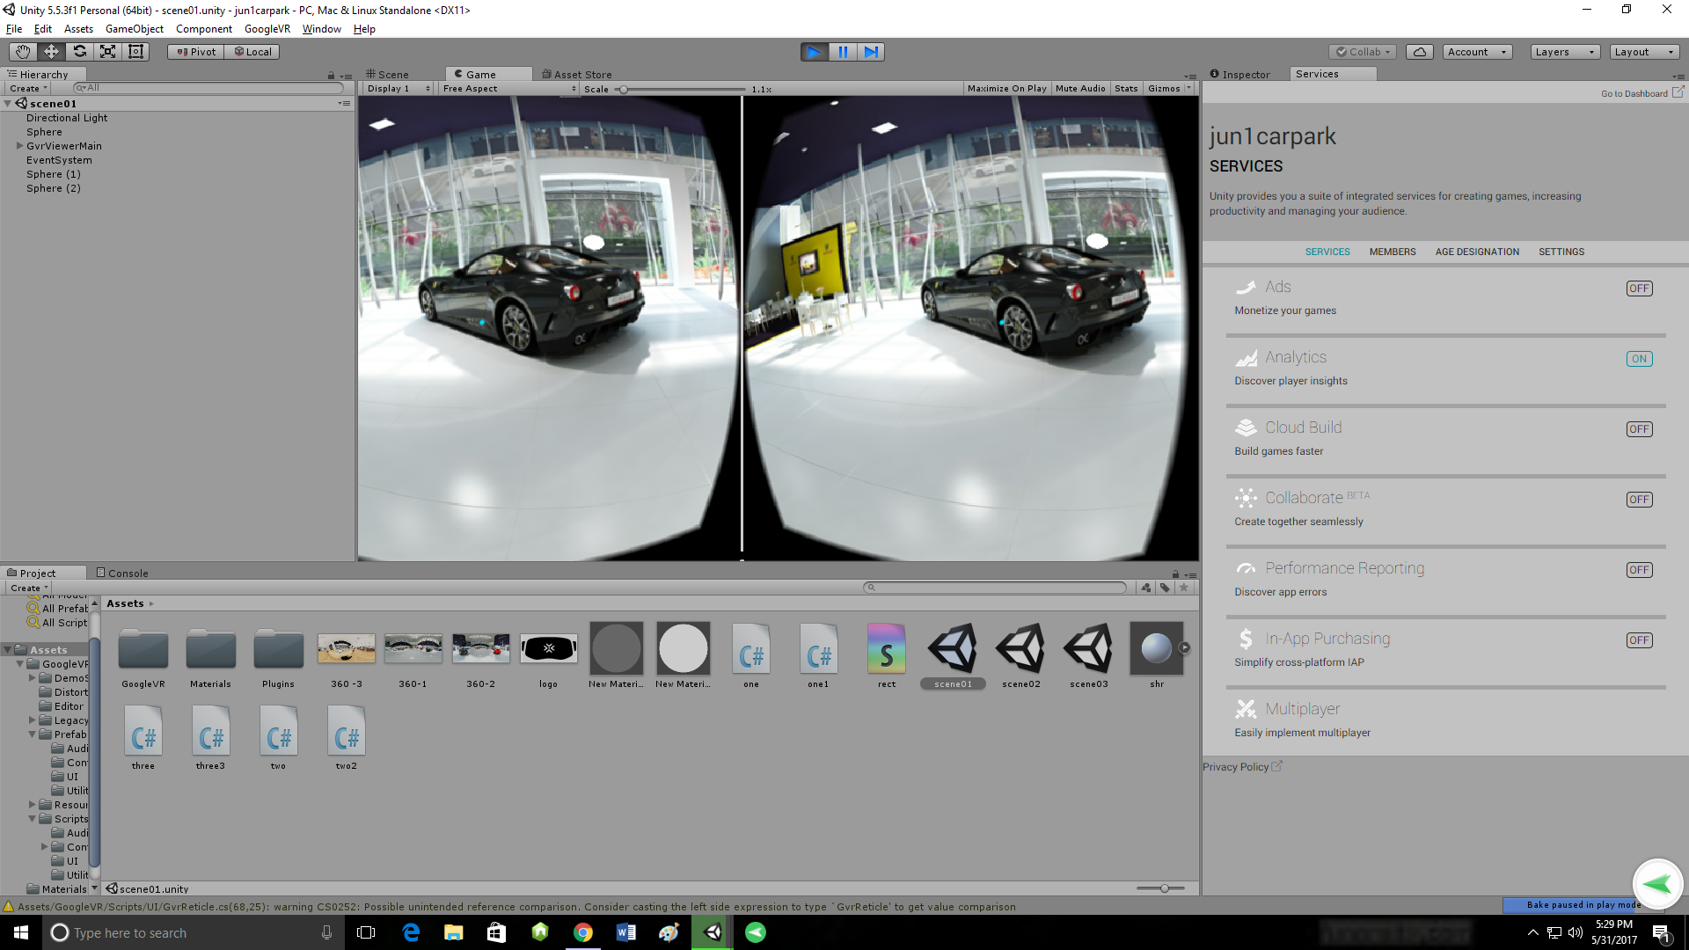

Fig 2.2 a) scene01

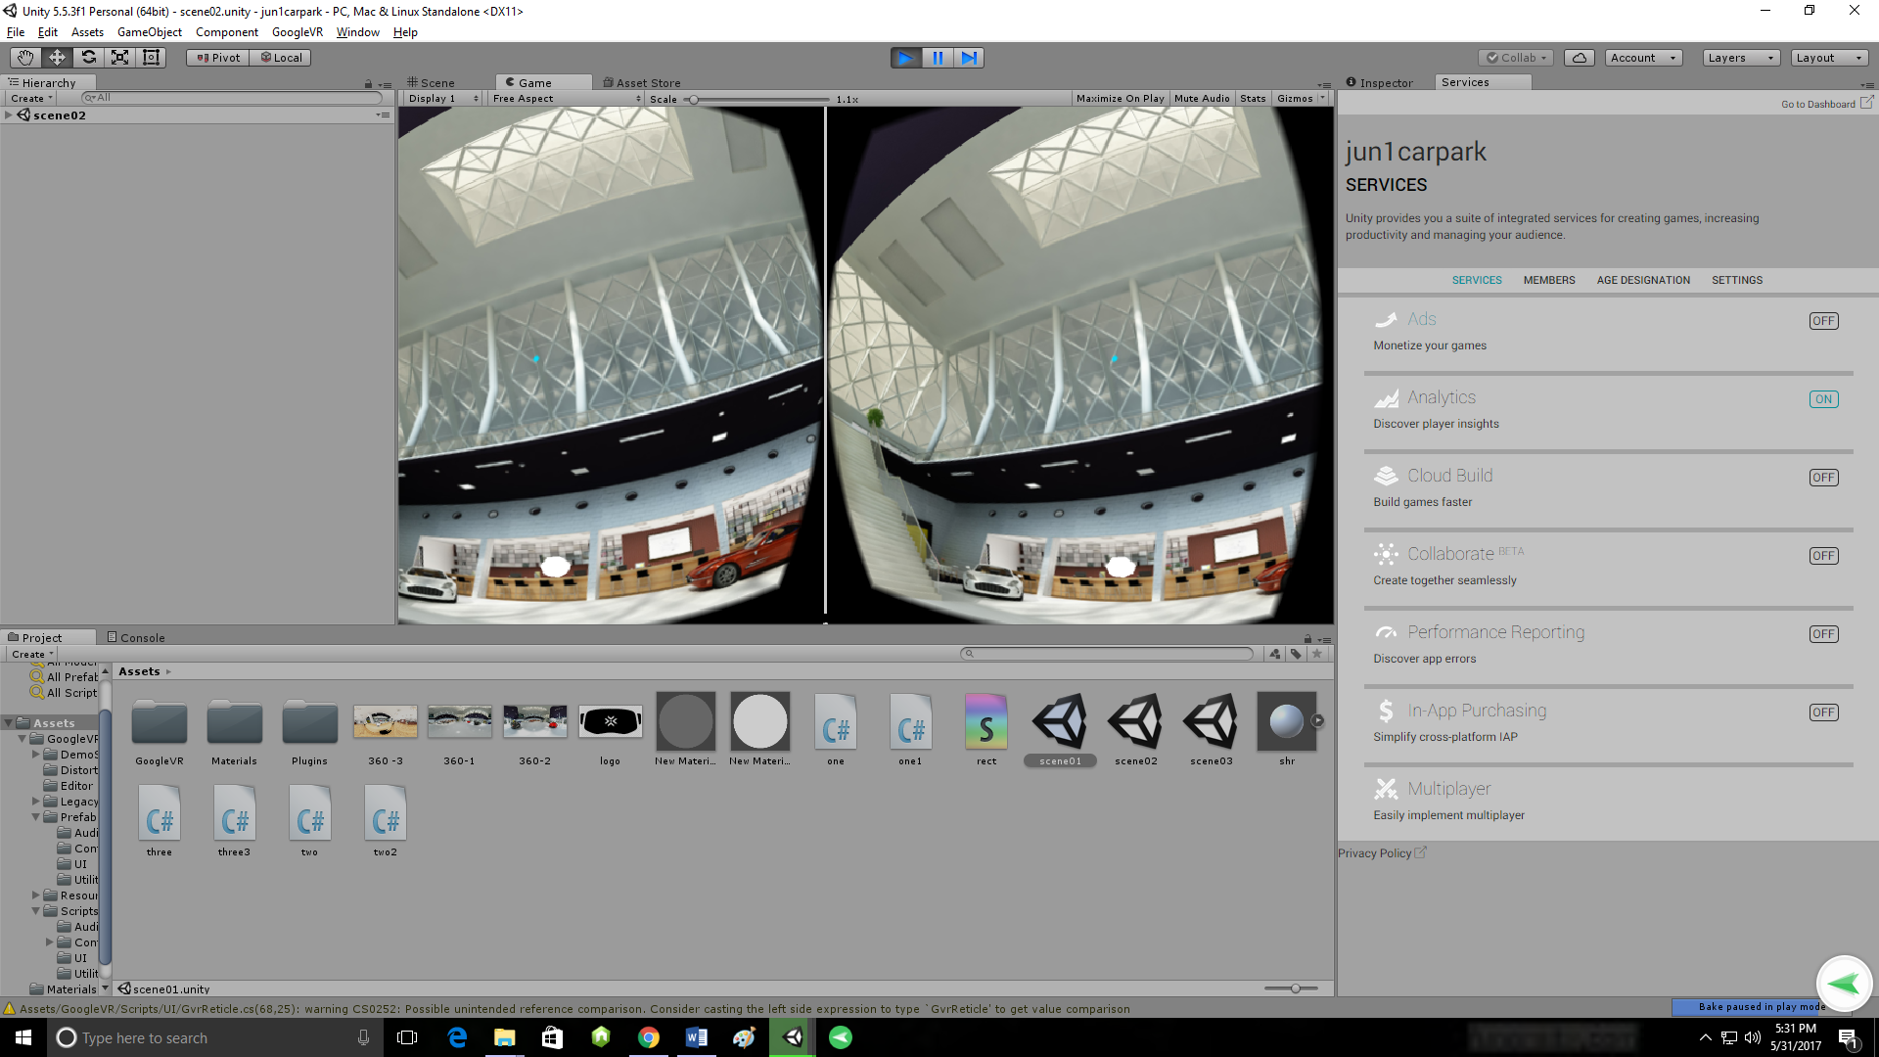

Fig 2.2 b) scene02

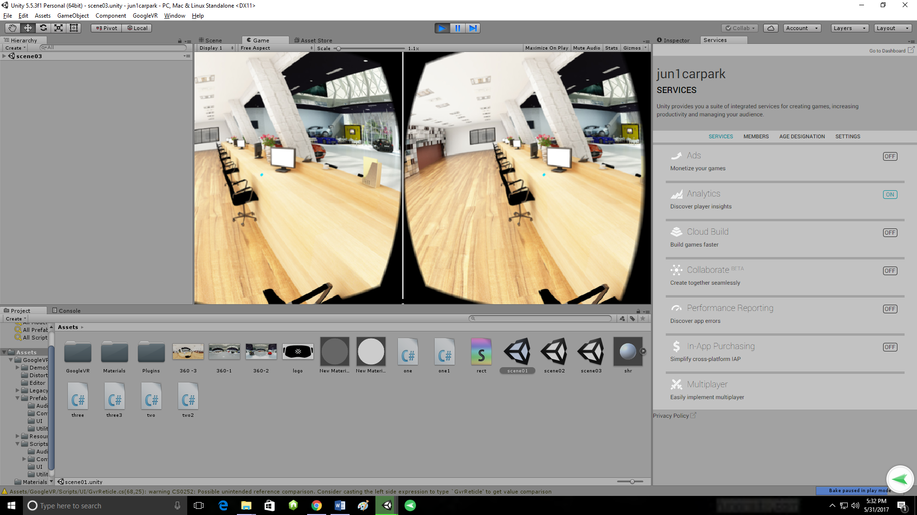

Fig 2.2 c) scene03

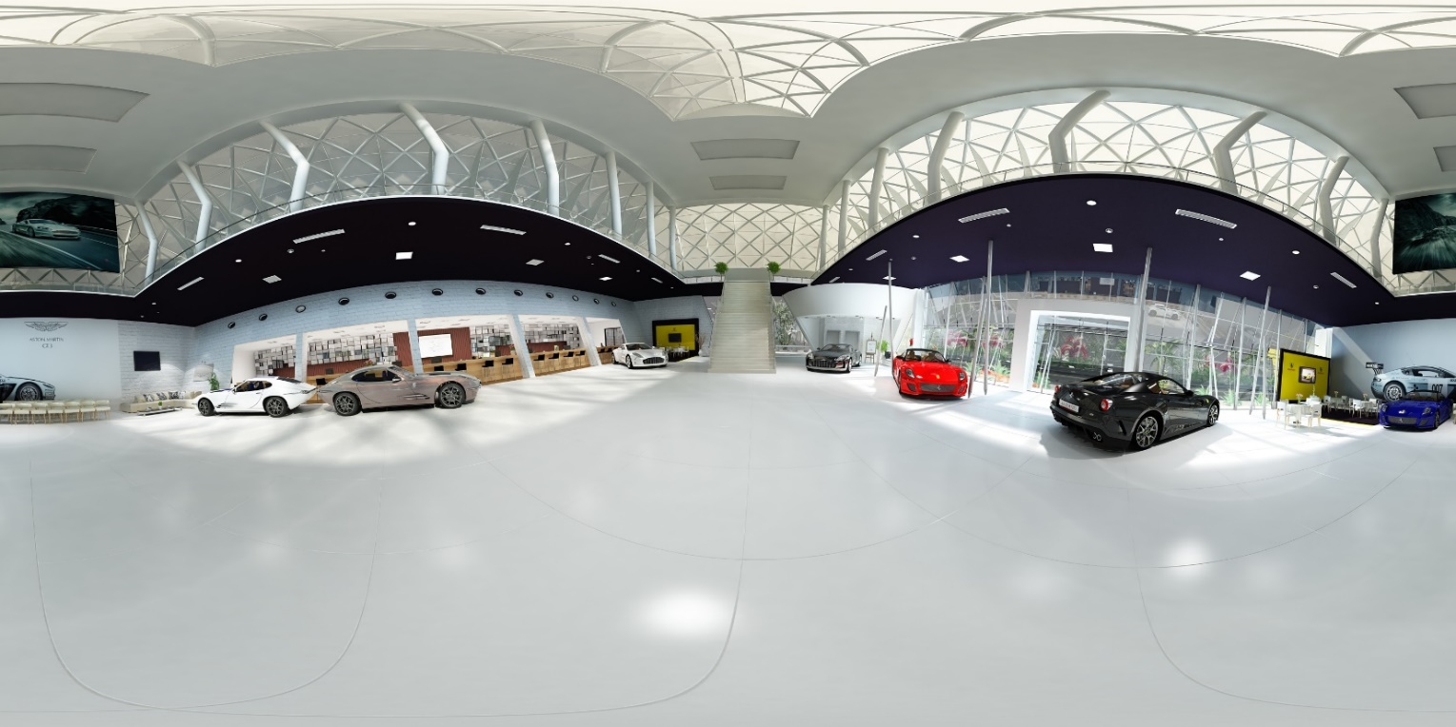

Fig 2.2 d) panaromic image of car showroom-1

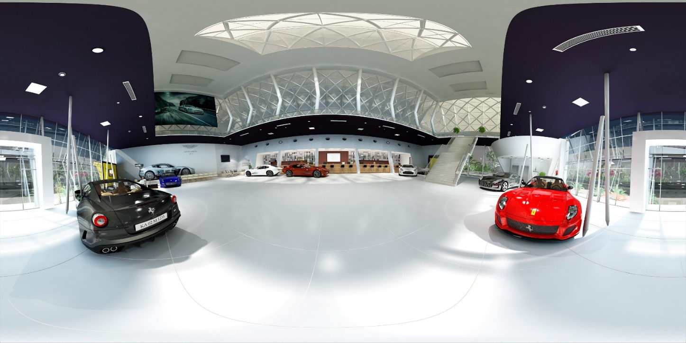

Fig 2.2 e) panaromic image of car showroom-2

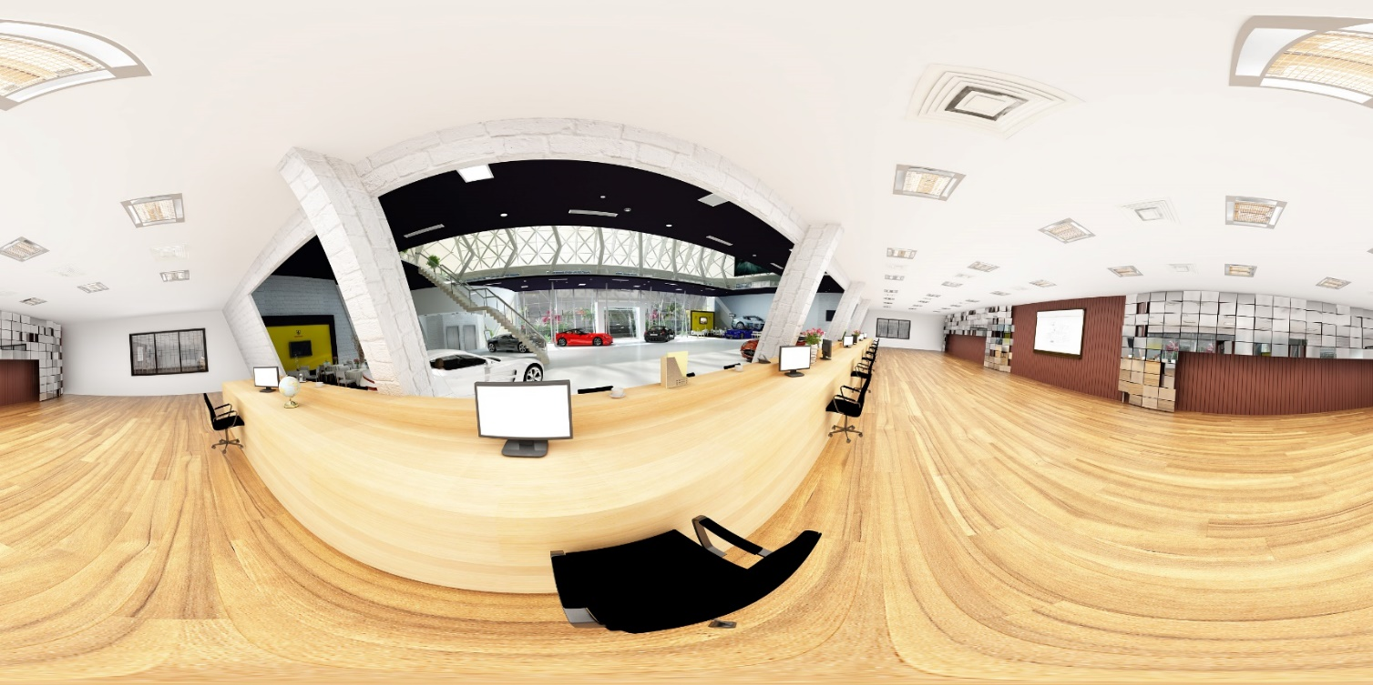

Fig 2.2 f) panaromic image of car showroom-3

2.2.4 Synchronization

For synchronizing the application with the head mounted device we have to deploy the project as an android application. To do so we have to install the android sdks of api level 8 to apilevel 22.

The googlevrsdk has two cameras. One is for left eye and other one is for right eye. unity VR adds the ability to target vr devices from directly within unity without the need for external plugins. It provides a base API and feature set with the goal forward compatability for devices and software. The provided API surface today is minimal by design and will expand as we learn more about the needs of VR developers to convert the unity project to android app we need android sdk and jdk. In the menu go to file->build settings->android->playersettings->identificaction->bundle identifier and set the name to be “com.pricoltechvr.project” in the meu go to file->build settings->android->click build and save the file extension as “.apk”.

We can interact with the android app using a hmd. eg: vr box



Fig 2.2 g) vr box

2.3 USE TOUCH GESTURES TO ROTATE AND CHANGE THE MATERIAL OF A 3D MODEL

2.3.1 TOUCH APP :-

The project “ use touch gestures is to rotate a 3d model” it is used to describe the status of a finger touching the screen. Devices can track a number of different pieces of data about a touch on a touchscreen, including its phase (ie, whether it has just started, ended or moved), its position and whether the touch was a single contact or several taps. Furthermore, the continuity of a touch between frame updates can be detected by the device, so a consistent id number can be reported across frames and used to determine how a particular finger is moving.

2.3.2 DESIGNING

* In this project the software used to develop the project is “unity”. The designing of the 3d models were downloaded from the hq classic arm chair, pack gesta furniture ie. From the asset store in unity with the extension of .fbx.
* Create materials for the 3d models using assets folder->right click->create->material
* Download the textures for furniture models from the web.

Initially we set the main camera and also used a directional light which is a typically simulates sunlight and a single light can illuminate the whole of a scene. Scenes contain the objects of our game. Then place all the objects in the scene and adjust the scale, transform and rotation using inspector settings. A material defines which shader to use for rendering this material. After applying the material to the 3d model, the shader used is legacy shaders->diffuse detail and then select the texture.

2.3.3 CODING AND TOUCH INTERACTION:-

In unity the programming language used is c#. Here the vector3 is used for representation of 3d vectors and points. This structure is used throughout unity to pass 3d positions and directions around. It also contains functions for doing common vector operations. Besides the functions listed below, other classes can be used to manipulate vectors and points as well.

Create a script called “touchh” this is used to rotate the chair if the user gazed at the chair for 2 seconds.

SOURCE CODE :-

using UnityEngine;  
using System.Collections;  
  
[RequireComponent(typeof(MeshRenderer))]  
  
public class touchh : MonoBehaviour   
{  
  
    #region ROTATE  
    private float _sensitivity = 1f;  
    private Vector3 _mouseReference;  
    private Vector3 _mouseOffset;  
    private Vector3 _rotation = Vector3.zero;  
    private bool _isRotating;  
      
      
  
    #endregion  
   
    void Update()  
    {  
        if(_isRotating)  
        {  
            *// offset*  
            _mouseOffset = (Input.mousePosition - _mouseReference); *// apply rotation*  
            _rotation.y = -(_mouseOffset.x + _mouseOffset.y) * _sensitivity; *// rotate*  
            gameObject.transform.Rotate(_rotation); *// store new mouse position*  
            _mouseReference = Input.mousePosition;  
        }  
  
    }  
  
    public void OnMouseDown()  
    {  
        *// rotating flag*  
        _isRotating = true;  
  
        *// store mouse position*  
        _mouseReference = Input.mousePosition;  
    }  
  
    public void OnMouseUp()  
    {  
        *// rotating flag*  
        _isRotating = false;  
          
    }  
}

Add this script to the 3d model and add a component called event trigger for pointer enter,pointer up and set the functions .

Now play the project in the editor.

TO CHANGE THE MATERIAL OF A 3D MODEL:-

To change the material of a 3d model we have to trigger the buttons to the 3d model i.e the gameobject.

SOURCE CODE :-

using UnityEngine;

using System.Collections;

// Change renderer's material each changeInterval

// seconds from the material array defined in the inspector.

public class colorchangg : MonoBehaviour

{

public Material[] materials;

public float changeInterval = 0.33F;

public Renderer rend;

void Start ()

{

rend = GetComponent<Renderer> ();

rend.enabled = true;

}

void Update ()

{

}

public void changecolor()

{

if (materials.Length == 0)

return;

// we want this material index now

int index = Mathf.FloorToInt(Time.time / changeInterval);

// take a modulo with materials count so that animation repeats

index = index % materials.Length;

// assign it to the renderer

rend.sharedMaterial = materials[index];

}

}

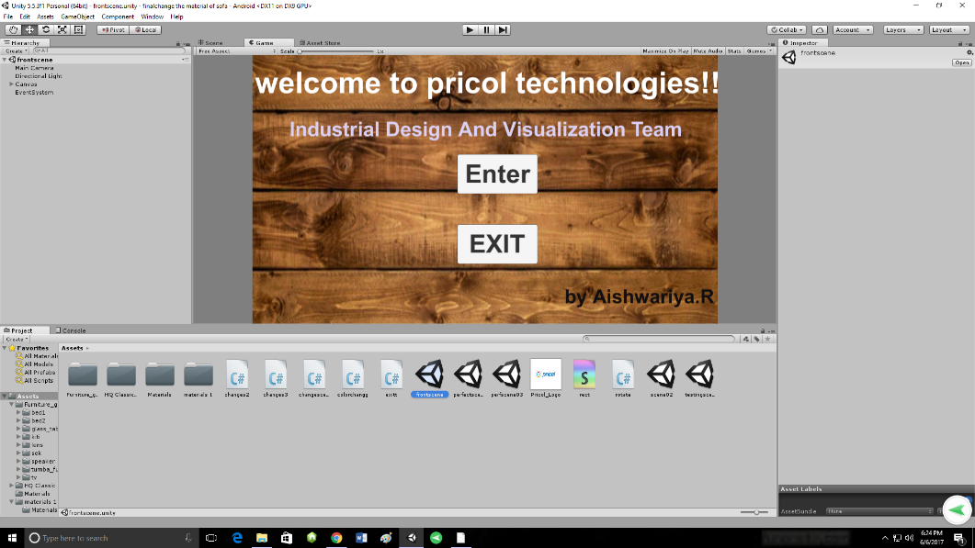

Fig 2.3 a) The welcoming page of the app

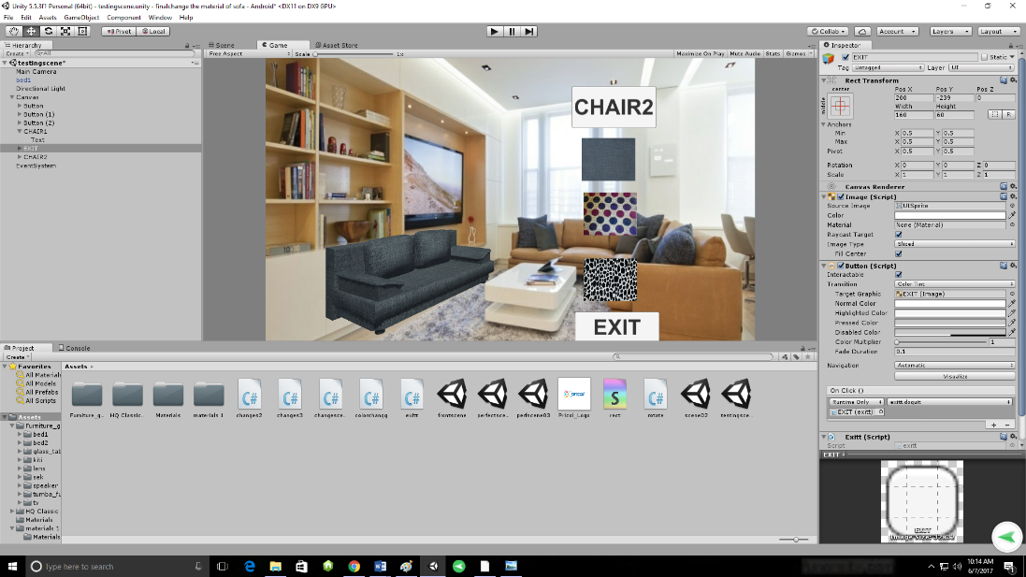

Fig 2.3 b) image of sofa model with buttons

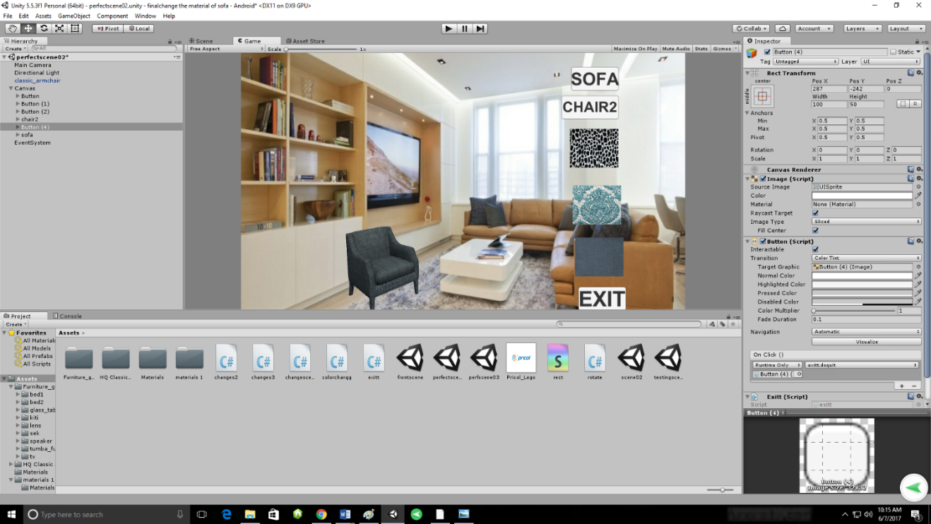

Fig 2.3 c) image of chair model with buttons

2.3.4 Synchronization

For synchronizing the application we have to deploy the project as an android application. To do so we have to install the android sdks of API level 8 to API level 22.

To convert the unity project to android app we need android sdk and jdk. In the menu go to file->build settings->android->playersettings->identificaction->bundle identifier and set the name to be “com.pricoltechvr.project” in the meu go to file->build settings->android->click build and save the file extension as “.apk”.

We can interact with 3d model in the android app using a finger to touch ,change the materials of a model and rotate the model.

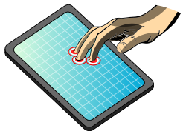

Fig 2.3 d) Touch interaction

CONCLUSION

* Pricol Technologies internship programme has offered me a great opportunity to grow and develop. It has propelled me to be able to overcome challenges and develop my career. I learnt extensively about virtual reality and details about 3d modeling, the relevance of industrial design and visualization used in industries. The programme has enhanced my critical thinking and analytical skillsas well as improved my professional and ability to work in a multicultural environment. Working in Pricol Technologies as an intern was not only an honour and privilege but a lifelong experience that will forever shape my professional life. I am very appreciative of this opportunity and forever grateful to Pricol Technologies for giving the opportunity to not work as an intern but also enabled me enhance my skills in technology and communication – this i believe epitomised my intern experience in Pricol Technologies.